September, 17 2015

Run for the Ribbons Inc.

Official Horse Show Rain Date Policy

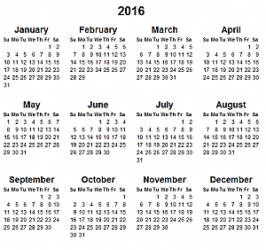
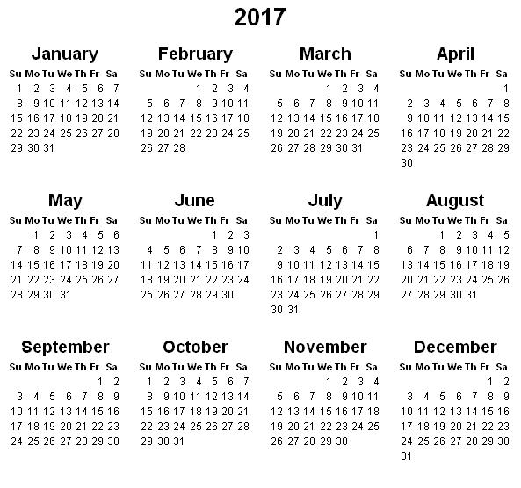
Run for the Ribbons Inc. has made a commitment to hosting no less than five hunter/jumper horse shows at Cedar Lock Farm during the series lasting one year to both sponsors and participants. As of the 2015-16 show year and continuing on, the series formally begins in March and ends in February of the following year. Cedar Lock Farm reserves the right to host these five Run for the Ribbons Inc. Horse Shows during the months of May, September, October, January, and February. November will also be assigned with a date, however, will only be set as our reserve month, in which case we would commence with a show in November due to the cancellation of both the original and rain date of one official month’s show. March will be the second reserve month in the case of a January or February show being cancelled along with their rain dates. With each month’s official show date, there will now also be an official rain date accompanying it when the show date is confirmed and announced. Shows will be cancelled in advance no later than 24 hours prior to the original show date, in which case the assigned rain date will become the new official show date. This policy is relevant to the remaining 2015-16 show year. Run for the Ribbons Inc. and Cedar Lock Form will not be held accountable for any expenses spent on travel, shipping or stabling in the case of inclement weather and show cancellation. Only prepaid entry fees will be reimbursed in case of cancellation due to inclement weather.
March

Reserve Month B
April

2016-17 Year- End Awards Banquet
2016-17 End Show Year
2017-18 Start Show Year

Summer Break
November

Reserve Month A
December

Fundraiser
2015-16 End Show Year
9
20
2016-17 Start Show Year
April

2015-16 Year- End Awards Banquet
March

Reserve Month B

Summer Break
December

Fundraiser
November

Reserve Month A

